EXPERIMENT 6

DML COMMANDS (COLLEGE SCHEMA)

Aim:

* Insert 5 instances into the tables created in experiment 6.
* Display the tables.
* Add attribute course to student table then insert values.
* Use update to set course for students.
* Delete an attribute.
* Insert 5 instances into the tables created in experiment 6.





* Display the tables.

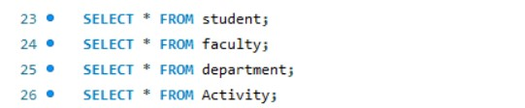

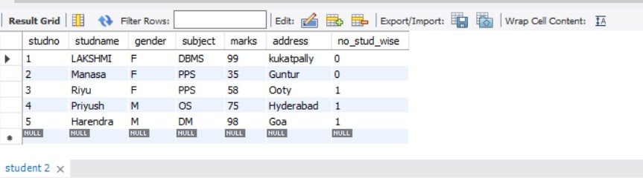

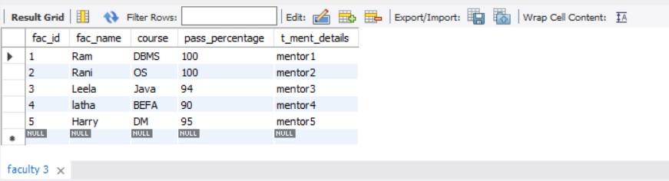

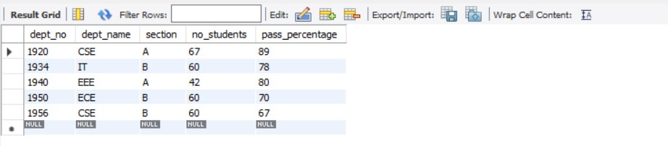

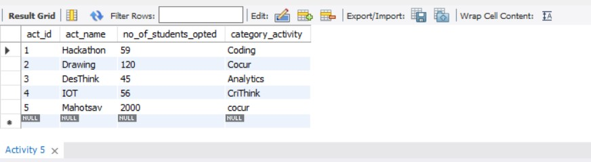

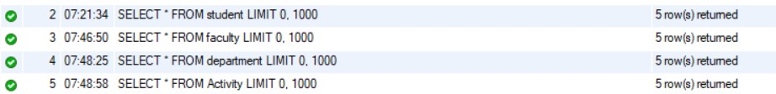

* Add attribute course to student table then insert values.
* Use update to set course for students.

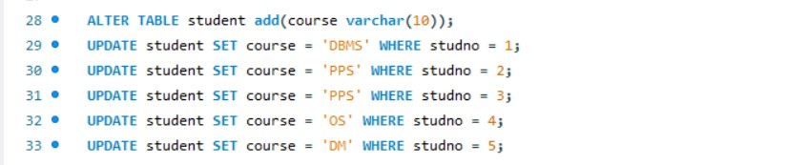  
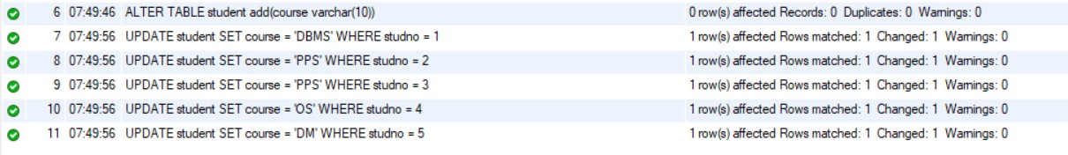

* Delete an attribute.

C:\Users\sukha\OneDrive\Desktop\Telegram Desktop\Activity1\activity1\s_12.jpg

C:\Users\sukha\OneDrive\Desktop\Telegram Desktop\Activity1\activity1\s_13.jpg